**Categorizing behavior similarities for modeling:**

In discrete model the six basic emotions are much more expressible using the natural language. These basic emotions are immutable throughout the evolutionary process.

The language based categorization corresponds to unique response pattern. In continuous model, different emotions having same value in a particular dimension are indistinguishable. So to create a set of emotions on the basics of behavior similarities language based basic categorization should be used.

**Step1: Getting Subjects Emotional State.**

**COMMONLY used SOURCES by researchers in different Affective Computing Research domains:**

1. Application collecting data on user's interaction and questions were asked on some interval.
2. Users were asked to perform set of gestures that exemplify each emotions.
3. Users were asked to choose the products which they like, dislike or value most. During questionnaire section they were asked questions related to products instead of directly asking about the emotions.
4. Website containing questionnaire is created to collect data interaction.
5. Subjects in windowless test room, were prompted with evaluated pictures of people making different emotional gestures.
6. An app was created , saving gesture , time and location
7. Subjects were asked to perform different body movements for different emotional states
8. Encoder communicate with Decoder through hand touch based on the displayed emotion sign board and Decoder finds the emotion conveyed.
9. A touch based game was created and after each level of the game , subjects were given a self assessment questionnaire consisting of a list of emotion words
10. Subjects were asked to install a mobile app and record gesture and emotion for atleast 15 days

**Plotting Emotions**

Using **Geneva Emotion Wheel (GEW) Version 3.0**

Description**: http://www.affective-sciences.org/gew**

**Example of Format For Questionnaire from GEW model :**

Link: **https://docs.google.com/document/d/1WFWpaqp02R7i8ynmVunGpK8y9qqgA7tf_YI5AD_tx-Y/edit?pli=1#heading=h.gjdgxs**

**Plotting of emotions on GEW model :**

Taking a bottom up approach ,

Subjects emotional state can be recorded without considering abstract states like Excited, Boredom, Frustrated and Relaxed..

Hence this makes subject to express emotion in an exact way.

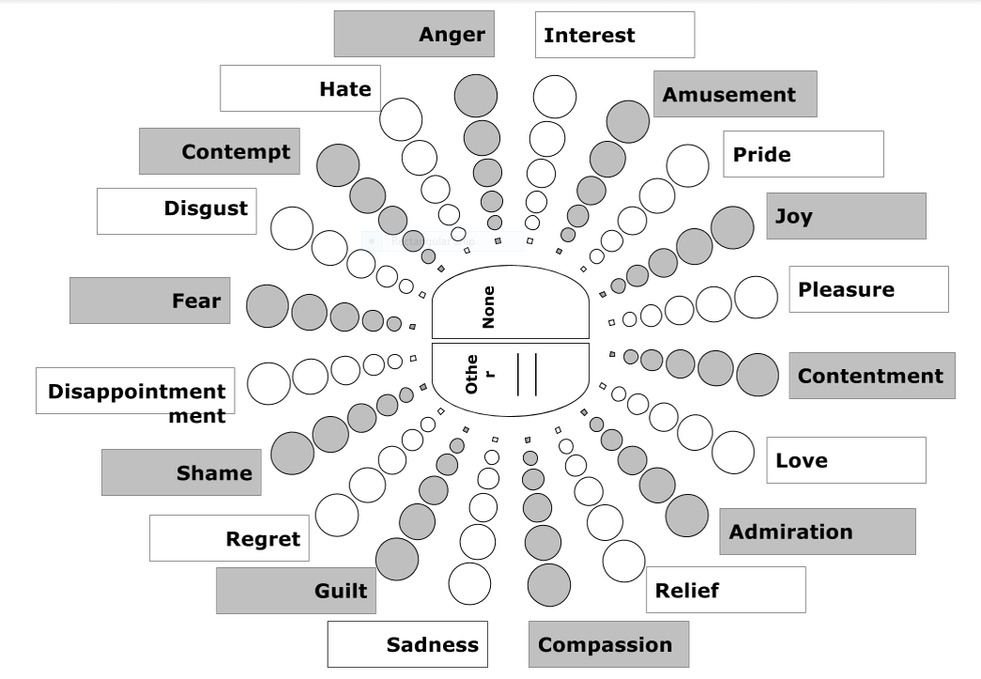

**Geneva Emotion Wheel (GEW) Version 3.0**

Abstracting Behavioral Emotional Similarities:

Mapping of similar emotional behavioral characteristics to 4 states namely Frustrated, Excited, Boredom and Relaxed.

00This mapping can prove useful for both similar behavioral application response and developing mobile gestures conclusions for emotional states.

High control / power

High negative state

High positive state

Low positive state

Low negative state

Negative valance

Positive valance



Low control / power

**Abstract Emotions from GEW Model**

**Some cited references:**

[1] Fuzzy model of dominance emotions in affective computing, Neural Computing and Applications, 2014-11-01.

[2] Emotion Recognition through Multiple Modalities: Face, Body Gesture, Speech, Book Title: Affect and Emotion in Human-Computer Interaction, Book Subtitle: From Theory to Applications, pp 92-103

[3]. Emotional Experience and Interaction Design, Book Title: Affect and Emotion in Human-Computer Interaction, Book Subtitle: From Theory to Applications, pp 116-129.

[4]Computational Affective Sociology, Book Title: Affect and Emotion in Human-Computer Interaction, Book Subtitle: From Theory to Applications, pp 23-34

[5] Comparing Two Emotion Models for Deriving Affective States from Physiological Data, Book Title: Affect and Emotion in Human-Computer Interaction, Book Subtitle: From Theory to Applications, pp 35-50

[6] CaptureMyEmotion: A mobile app to improve emotion learning for autistic children using sensors, Computer-Based Medical Systems (CBMS), 2013 IEEE 26th International Symposium on 20-22 June 2013, pp:381 - 384

[7] Designing gestures for affective input: an analysis of shape, effort and valence, Item Type: Conference or Workshop Item (Paper), ID Code: 145, Deposited By: Interaction Researcher, Deposited On: 07 Sep 2009, Last Modified:18 Nov 2009 15:54

[8] Touch communicates distinct emotions. Hertenstein, Matthew J.; Keltner, Dacher; App, Betsy; Bulleit, Brittany A.; Jaskolka, Ariane R., Emotion, Vol 6(3), Aug 2006, 528-533. http://dx.doi.org/10.1037/1528-3542.6.3.528

[9] What Does Touch Tell Us about Emotions in Touchscreen-Based Gameplay?, ACM Transactions on Computer-Human Interaction (TOCHI) TOCHI Homepage archive, Volume 19 Issue 4, December 2012, http://dl.acm.org/citation.cfm?id=2395138

[10] Identifying emotions expressed by mobile users through 2D surface and 3D motion gestures, Céline Coutrix CNRS, Laboratoire d'Informatique de, Grenoble Nadine Mandran CNRS, Laboratoire d'Informatique de, Grenoble, Published in: UbiComp '12 Proceedings of the 2012 ACM Conference on Ubiquitous Computing, pp: 311-320